Impact of Government action

Countries objectives

Ever since the Kyoto protocol in 1997, countries have set objectives about reducing their emissions and pollution.

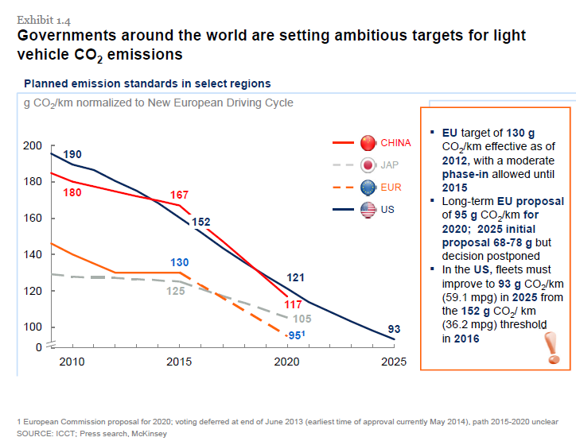

Apart from the development of renewable energies, the need for a new fleet of sustainable vehicles has appeared to be essential to attain these objectives. In order to help such a development, many countries have decided to take measures in favour of the EV market, including not only the vehicles in themselves, but also the charging stations that support the network. We will more specifically consider the example of the European community of countries.

Countries measures to help the EV Market

Subsidies

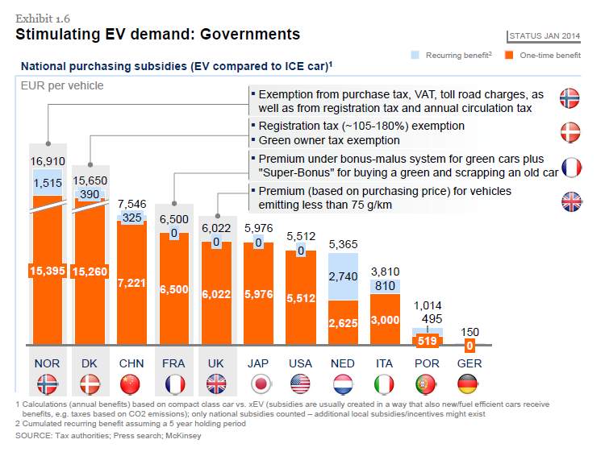

Subsidies are one of the best weapon countries have to favor a specific market. In this case, they provide a certain amount of money when the car is bought, in order to make the EV market financially more appealing. Even though China, Japan and the USA are in very good position, many European countries also arrive in a very good position when it comes to subsidies per car.

But all actions in a country are not governmental. Cities also try their best to improve the development of the EV market, in a regional scale. For example, the city f Paris has created the Autolib program, in which people can use EVs that belong to the city, in the same way than bikes. Whether you have a card or not, you can pay a very small amount of money to a station, get a car, and put it back in one of the city’s many stations. Other actions are done in many cities. They provide not only subsidies, but also programs such as EV car sharing services. Also, many actions favoring EV users letting them use priority lanes, use parking lots, ..

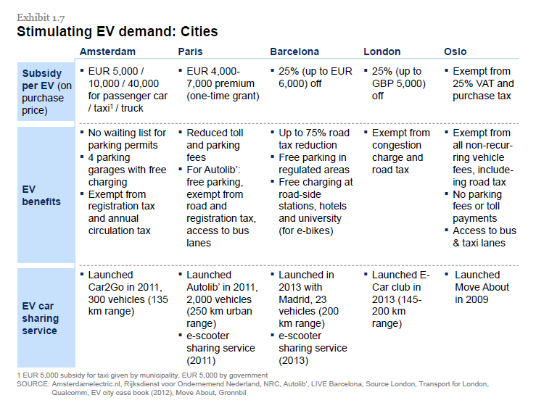

Charging stations network

Another kind of action is the development of the charging stations network, essential to support the EVs’ fleet in a country.

Many countries have implemented policies regarding the development of charging stations’ network. These policies include financial incentives and subsidies (e.g. 50 million for France), determination of showcase regions, support of R&D, tax incentives to support the creation of a charging infrastructure, public advertisement and shows, …

The graph above shows us that the most efficient actions are the tax incentives (Netherlands), use of showcase regions (Germany), and of course subsidies (UK, France, Germany).

Results

The impact on the sales of charging stations is pretty obvious, and, apart from Africa, the increase in the implementations of charging stations is pretty huge.

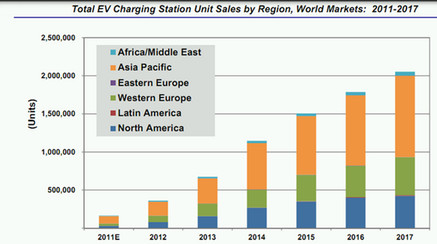

And the combined effect of EV promotion from countries/cities, and the development of the charging stations network is a similar increase in the sales of EV.

